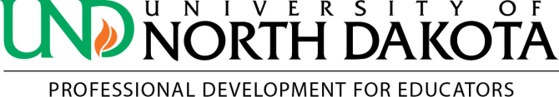
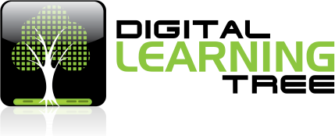
in partnership with

T&L 2900—Using Open Educational Resources (OERs) to Create K12 Curriculum

Course at a Glance
Instructor/Presenter: Jessie Chuang Length: 45 hours - Complete in 4 months Dates: Enroll Anytime

Number of Professional Development Credits: 3

Introduction

Teachers play a monumental role in facilitating opportunities for students to become critical thinkers, proactive citizens, and creative contributors to the world around them. But it’s crucial that teachers are afforded the same opportunities to grow and learn new cutting edge digital teaching skills for todays “Digital Kids.” Teachers will learn how to build capacity in using Open Educational Resources (OERs), sharing OERs and building OERs, they will connect with like-minded educators and communities, and establish a strong portfolio of an educator as a creator of digital curriculum and lessons.

In the contemporary educational landscape, emerging participatory practices facilitated by technological and socio-cultural developments have given rise to a new model of knowledge circulation. Such developments suggest that teachers need to foster “participatory learning” where communities of learners work together to build and re-build knowledge. In this course, you will learn why OERs are important building blocks for participatory learning. . The Common Core State Standards also promote the idea that students should “use technology . . . to produce and publish writing and to interact and collaborate with others.”

Participatory learning, as a pedagogical model, underscores the urgency of facilitating learning experiences that help build the capacity necessary to contribute in today’s society. But it goes beyond questions of technology access; it’s about cultural competencies and social skills. The quickening pace of technological change means we can barely envision the actual contexts in which our students will use what they are learning in school. Some of the most important contexts will certainly include digital networks of user-generated content that is persistent, searchable, and replicable (Boyd, 2008).
The new adoption of K-12 Common Core State Standards provides an excellent opportunity to develop high-quality, openly licensed K-12 courseware that is aligned with these standards. Also, OER provides institutions and educators access, at no cost, to the means of production to develop their competence in producing educational materials and instructional design.

Learning Objectives

One important objective for participants is to learn how to learn from social networking and community of practice, so …

- Peer feedback and peer review are required.

- Participation is crucial.
- The final project of creating an OER resource is required. All the assignments and quizzes are to help you in the journey toward this final goal. The core of this course is project-based learning.
- Personal blog and Twitter accounts are required to join this course… learners always publish to authentic audiences. Through this way, learners build strong digital identities and participate in the real world with real experience.

Even if you are a social media novice, it’s absolutely fine to use this course as a starting point and begin to learn about using Twitter, blogging and utilizing Web2.0 tools like Google Document.

Through the activities in this course, you are expected to become:

- An avid blogger
- A fluent social media user
- A digital maker
- An OER community member
- A connected learner

Required Textbook and Materials

All materials and readings for this course will be provided in the course content, with links to online sources.

Assignments & Course Requirements

There are six components in this course that will contribute to the final achievement:

- Quests (quizzes): Finish each quiz after each lesson. The quizzes are designed to help you learn, their answers are hidden in the lessons.

- Missions (assignments): There is an assignment after each lesson, the mission description is revealed in it. 7 out of 14 missions are required, but you can do more to achieve more.

- Final Project: Creating an OER resource containing a minimum of one learning object (including videos, quizzes …) for the subject of your expertise. It could be built from scratch or from remixing open licensed resources and then published with the open license you preferred. The OER’s information will be added to your blog or ePortfolio. It's required for you to find a reviewer (learners from this course) for your project work who will use a provided rubric. This review will then be included in the final project.

- Participation: Learners will provide feedback on other's mission work (blog posts), raise discussion on the course forum, and answer questions or invite others to work together on the final project (not limited to those that join this course).

- Peer Review and Feedback: Review other learners’ works and give constructive suggestions or comments.

- Personal Learning Network (PLN): As you go through this course, do remember to build your PLN about OER and content creation. Provide a "Final Project" section about your personal learning network profile regarding your sources for professional development in OER.

Grading

This course is offered for S/U (satisfactory or unsatisfactory) grading.

S/U criteria: The bottom-line criteria to satisfactorily pass this course are scores of XP > 2600 and to finish at least the minimum items required with the requested quality:

- 7 out of 14 missions are required (self-evaluation and peer review)
- Final Project (evaluated by the instructor and at least one other learner)
- One peer review for other learner’s final project (evaluated by the instructor)

Concerning Rubrics for Scoring, which are provided in the course syllabus:

For rubrics I ~ VII, that are applicable to your learning object(s), the scores are 0, 1, 2, 3. If you get any item evaluated under a 2 from the peer learner and the instructor, please improve it and have the peer learner and the instructor re-evaluate it again.

For rubric VIII, the evaluation result will be only for reference, not resulting in pass / fail for the evaluation.

Scholastic Dishonesty

Students enrolled in this course are expected to be aware of the seriousness of scholastic dishonesty. Unacceptable behavior such as submitting someone else's work as your own, cheating on exams, or plagiarizing can result in failure of the course or other sanctions. For a more detailed description of these policies, please refer to the UND Code of Student Life; Appendix IIIa-3, at: http://und.edu/student-affairs/code-of-student-life/

