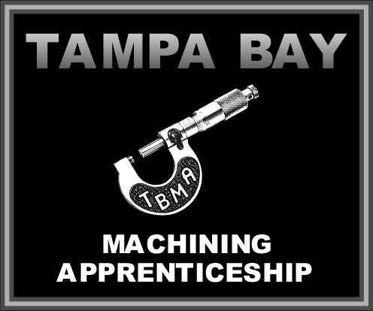

TBMA®

A State Registered Apprenticeship Program

2023/2024 Class Schedule
For Machine Trades
Apprenticeship Instructors

Hours: Monday & Wednesday 5:00pm – 9:00pm

Start Dates End Dates

1. Term August 14 – Monday October 23 – Monday

2. Term October 25 – Wednesday December 20 – Wednesday

3. Term January 08 – Monday March 06 – Wednesday

4. Term March 18 – Monday May 06 – Monday

5. Term May 8 – Wednesday July 3 – Wednesday

No School Days

- July 13 thru August 11 – Summer Break
- September 4 – Monday – Holiday
- September 6 – Wednesday – Day off
- September 25 – Monday – Pro Ed Day
- September 27 – Wednesday – Day off
- October 16 - Monday – Pro Ed Day
- October 18 – Wednesday – Day off
- November 20 – Monday – Thanksgiving Holiday
- November 22 – Wednesday– Thanksgiving Holiday
- December 25 – Monday – Christmas Holiday
- December 27 – Wednesday – Christmas Holiday
- January 01 – Monday – Christmas Holiday
- January 03 – Wednesday – Christmas Holiday
- January 15 – Monday – MLK Day
- January 17 – Wednesday – Day off
- February 19 – Monday – Pro Ed
- March 11 – Monday – Spring Break
- March 13 – Wednesday – Spring Break
- May 27 – Monday – Memorial Day
- May 29 – Wednesday - Day off

