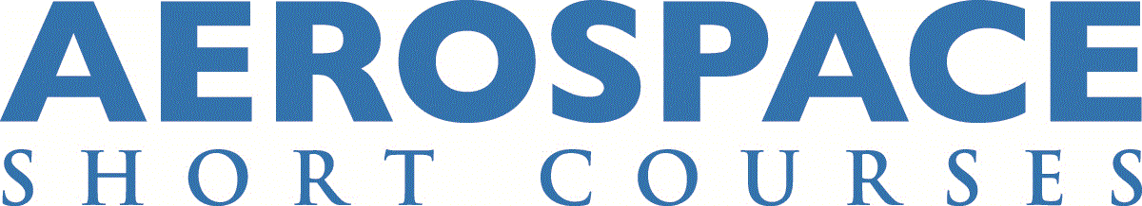

Aircraft Icing: Meteorology, Protective Systems, Instrumentation and Certification – ONLINE (AERO0065)
Instructors: Wayne R. Sand, Steven L. Morris

Course Description
This course covers meteorology and physics of aircraft icing: forecasting, finding and avoiding icing conditions, designing and evaluating ice protection systems; and certification of aircraft for flight into known icing conditions.

Learning Objectives
- Basic physics of aircraft icing
- Basic understanding of the meteorology of aircraft icing
- How to obtain icing forecast information to find or avoid icing conditions
- Background and discussion of key aircraft icing accidents
- An understanding of the icing problems associated with Supercooled Large Droplets (SLD)

Who Should Attend?
Designed for aerospace engineers, flight test and design engineers, test pilots, line pilots, meteorologists, FAA engineers and Designated Engineering Representatives (DERs), and program managers.

Course Highlights
- Description of aircraft icing, severity, types and photos
- Atmospheric aerosols
- Cloud physics of icing and conceptual cloud modes
- Ground icing
- Skew-T, Log P adiabatic diagrams
- Assessment of icing potential
- Critical icing parameters, theory and measurements
- Meteorology of SLD icing
- Finding and avoiding icing conditions
- Discussion of sources and meaning of available forecast information
- Ice accretion characteristics
- Effects of ice on aircraft performance
- Anti-ice and de-ice systems
- Icing instrumentation and detection
- Effect of SLD on aircraft
- Engine icing considerations
- Ice-testing methods
- Certification and regulations
- Conceptual methods

Course Outline
- Icing hazard description
- Atmospheric aerosols
- Cloud physics of icing
- Ground icing, atmospheric cooling mechanisms
- Conceptual cloud modes: convective clouds, stratiform clouds
- Skew-T, Log P adiabatic diagrams
- Icing environment analysis using Skew-T, Log P
- Assessment of icing potential
- Critical icing parameters, theory and measurements
- Meteorology of supercooled large drops (SLD icing)
- Finding/avoiding icing conditions
- New and current icing research
- Internet resources
- Ice accretion characteristics
- Effects of ice on aircraft performance
- Anti-ice systems
- De-ice systems
- Icing instrumentation, icing environment
- Icing detection
- Effect of SLD on aircraft
- Engine icing considerations
- Ice-testing methods
- Certification and regulations
- Computational methods
- Review and discussion

Classroom hours / CEUs
28.00 classroom hours
2.8 CEUs

Certificate Track
Aerospace Compliance
Aircraft Maintenance and Safety

Course Fees
Early online registration fee: $1,895*
Regular online registration fee: $2,095
*Early registration fee is available if you register and pay at least 7 days prior to the course start

Registration is open until the first day of the course; however, early registration is encouraged.
The online course fee includes individual access to the Zoom course meetings and to course materials, readings, videos, and resources in Blackboard, the University of Kansas Learning Management System. No additional textbook purchases are required outside the course fee.

U.S. Federal Employee Discount
This course is available to U.S. federal employees at 10% off the registration fee. To receive the federal employee discount, you must enter the code FGVT116 during the checkout process. Please note that you must validate your eligibility to receive this discount by entering your U.S. government email address (ending in .gov or .mil) when creating your online registration profile. This discount is available for both the early registration and regular registration fees.

Canada Department of National Defence Discount
This course is available to Canada DND employees at 10% off the registration fee. Please contact the DND Procurement Authority (DAP 2-3) for details. Please note that you cannot register using our online system when requesting this discount. This discount is available for both the early registration and regular registration fees.

Instructor Bios
Wayne R. Sand is an aviation weather consultant with expertise in aircraft icing tests, analysis of icing accidents and development of icing instrumentation. He also has extensive expertise in convective weather, winter weather and mountain weather. As former deputy director of the Research Applications Program at the National Center for Atmospheric Research, he developed aviation weather technology for the FAA. Previously, Sand was a member of the atmospheric science department at the University of Wyoming. He also conducted research on thunderstorms and convective icing while at the South Dakota School of Mines and Technology. Sand is co-holder of a patent on a technique for the remote detection of aircraft icing conditions. He holds a B.S. in mathematics and physical science from Montana State University, an M.S. in meteorology from the South Dakota School of Mines and Technology and a Ph.D. in atmospheric science from the University of Wyoming.

Steven L. Morris is a Principal and Manager of Colorado Operations for Engineering Systems Inc. (ESI), Colorado Springs, Colorado. Morris served as an officer and engineer in the U.S. Air Force for more than 24 years. His experience includes teaching, research and consulting in the areas of airplane design, stability and control, aerodynamics, flight simulation, aircraft icing and accident reconstruction. He is a co-author of Introduction to Aircraft Flight Mechanics: Performance, Static Stability, Dynamic Stability, and Classical Feedback Control. Morris is an Associate Fellow of AIAA and is a member and past Chair of the SAE Aircraft Icing Technology Committee. He received a B.S. in engineering sciences from the U.S. Air Force Academy, an M.S. in aeronautical engineering from the Air Force Institute of Technology and a Ph.D. in aerospace engineering from Texas A&M University.

This class is available for delivery at your company.
Your company can realize substantial savings by bringing an aerospace short course to your workplace. On-site delivery is ideal for organizations that need to train 10 or more employees on a specific topic. For more information on on-site course delivery, or to request a cost proposal, please contact us at 913-897-8782, or email us at ProfessionalPrograms@ku.edu.

CONTACT US:

KU Jayhawk Global
Aerospace Short Course Program
1515 St. Andrews Dr.
Lawrence, KS 66047
Email: jayhawkglobal@ku.edu
Phone: 785-864-6779 (Registration)

