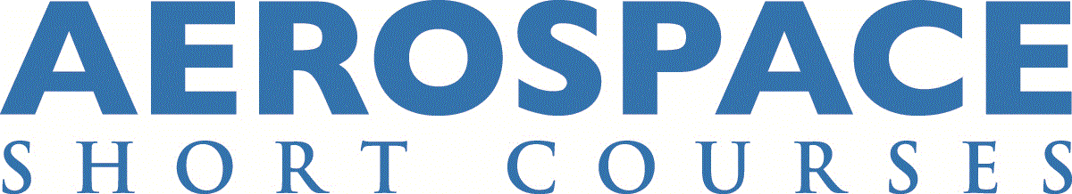

Electrical Wiring Interconnection System (EWIS) Safety Assessment - 25.1709 - ONLINE (AERO0245)

Instructor: Thomas N. Taylor

Course Description
This course will focus on the requirements and methods that can be used to demonstrate compliance to 14 CFR 25.1709 (EWIS Safety Analysis). The discussion will examine the use of FAA AC 25.1701-1 to prepare a Functional and Physical Analysis. The course will also include an overview of the EWIS requirements included in 14 CFR Part 25, subpart H.

Students will work in teams to gain hands-on experience building an EWIS Safety Assessment incorporating the information they learn as they progress through the course.

Learning Objectives
- The history and background of 25.1709
- The difference between 25.1309 and 25.1709
- Methodology and techniques for demonstrating compliance to 25.1709

Who Should Attend?
The course is designed for engineers, technicians and managers involved in the design and certification of Transport Category Aircraft. The course is intended for both Original Equipment Manufacturers (OEM) and aircraft modifiers.

Course Highlights
- A detailed review of FAA AC 25.1701-1C and 25.1709 flow diagram
- Practical EWIS example for new and modified aircraft
- 25.1709 Functional and Physical Analysis Development through Team Workshops

Course Outline
- Introductions
- Brief overview of EWIS definitions and regulations
- Traditional vs. EWIS philosophy
- Comparison of 25.1309 and 25.1709
- Introduction to 25.1709 EWIS Safety
- Project planning – resources, requirement, process and tool development, analysis
- System Requirement Definition, Validation and Verification
- 25.1709 functional analysis and AC 25.1701-1 flowchart
- Functional Hazard Assessment (FHA)
- Introduction to 14 CFR 25.1709 “Functional” Analysis
- Functional failure analysis team case study
- Introduction to 14 CFR 25.1709 “Physical” Analysis
- EWIS threat definition
- Multiple system consideration
- Continuation of physical failure analysis methodology
- New airplane design vs. Airplane modification
- EWIS safety assessment documentation
- CFR 25.1709 team wrap-up
- Final 25.1709 discussion and questions
- Lessons learned and EWIS take-aways
- EWIS final examination

Classroom hours / CEUs
31.50 classroom hours
3.15 CEUs

Certificate Tracks
Aerospace Compliance
Aircraft Maintenance and Safety
Avionics and Avionic Components
Electrical Wiring Interconnection System (EWIS)

Course Fees
Early Online Registration fee: $2,195*
Regular Online Registration fee: $2,395
*Early registration fee is available if you register and pay at least 7 days prior to the course start

Registration is open until the first day of the course; however, early registration is encouraged.
The online course fee includes individual access to the Zoom course meetings and to course materials, readings, videos, and resources in Blackboard, the University of Kansas Learning Management System. No additional textbook purchases are required outside the course fee.

U.S. Federal Employee Discount
This course is available to U.S. federal employees at 10% off the registration fee. To receive the federal employee discount, you must enter the code FGVT116 during the checkout process. Please note that you must validate your eligibility to receive this discount by entering your U.S. government email address (ending in .gov or .mil) when creating your online registration profile. This discount is available for both the early registration and regular registration fees.

Canada Department of National Defence Discount
This course is available to Canada DND employees at 10% off the registration fee. Please contact the DND Procurement Authority (DAP 2-3) for details. Please note that you cannot register using our online system when requesting this discount. This discount is available for both the early registration and regular registration fees.

Instructor Bio
Thomas (Tom) Taylor is an FAA Consultant DER, ODA Authorized Representative/AR Advisor and Associate Technical Fellow (ATF) at The Boeing Company, with 29 years in commercial and military aircraft electrical design and certification experience. Tom was the technical focal and DER/AR during the development of the 787-8 and was responsible for the certification of the 787-9, which was the first commercial airplane fully certified to the EWIS regulations. Tom also provides engineering consultation, training, and aircraft certification services through his company, Taylor Aerospace Consultants. He has a Bachelor of Science in Mechanical Engineering from Washington State University.

This class is available for delivery at your company.
Your company can realize substantial savings by bringing an aerospace short course to your workplace. On-site delivery is ideal for organizations that need to train 10 or more employees on a specific topic. For more information on on-site course delivery, or to request a cost proposal, please contact us at 913-897-8782, or email us at ProfessionalPrograms@ku.edu.

CONTACT US:

KU Jayhawk Global
Aerospace Short Course Program
1515 St. Andrews Dr.
Lawrence, KS 66047
Email: jayhawkglobal@ku.edu
Phone: 785-864-6779 (Registration)

