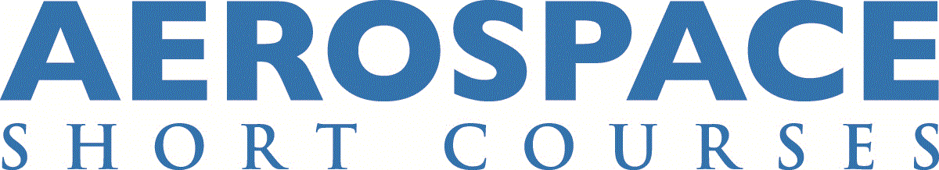

Aircraft Propulsion Systems: Principles and Practices (AERO0080)
Instructor: Saeed Farokhi

Course Description
This course studies the basic principles of propulsion systems with emphasis on jets and fan systems. It also includes the study of inlets and nozzles, compressors, burners, fuels, turbines and jets culminating in design and off-design engine analysis, performance and environmental considerations. The impact of propulsion system integration on external aerodynamics and (noise and IR) signature reduction is also presented, along with an introduction to novel concepts in propulsion.

Course Highlights
- Modern gas turbine engines, Geared Turbofans, ATP
- Component design guidelines
- System performance evaluation
- Propulsion-Airframe Integration
- Future directions in propulsion and power

Who Should Attend?
This course is intended for practicing engineers in the aircraft industry, engineering faculty (mechanical, aerospace, industrial and power), engineering students (undergraduate and graduate), government officials working in the power and propulsion sector, decision makers who need a working knowledge of gas turbines and contractors.

Learning Objectives
- First principles approach to jet engine components and their design guidelines
- Integrate components to form a complete Propulsion System
- Analyze the performance of any conventional and unconventional jet engine
- Understand propulsion-aircraft system integration issues
- Understand tradeoffs involved in “optimal” design

Course Outline
Day 1
Morning Sessions
- Introduction to Gas Turbines Engines
- Review of Aero-Thermodynamics
Afternoon Sessions
- Gas Turbine Engine Cycle Analysis –Part I
- Gas Turbine Engine Cycle Analysis –Part II

Day 2
Morning Sessions
- Aircraft Intake Systems- Part I
- Aircraft Intake Systems- Part II
Afternoon Sessions
- Combustion Principles & Combustion Chamber Aerodynamics
- Problem Solving, Practice and Interim Review

Day 3
Morning Sessions
- Axial-Flow Compressor Aerodynamics & Design Principles- Part I
- Axial-Flow Compressor Aerodynamics & Design Principles- Part II
Afternoon Sessions
- Centrifugal Compressor Aerodynamics
- Problem Solving, Practice and Interim Review

Day 4
Morning Sessions
- Axial-Flow Turbines – Aerodynamics & Cooling - Part I
- Axial-Flow Turbines – Aerodynamics & Cooling - Part II
Afternoon Sessions
- Aircraft Exhaust Systems
- Problem Solving, Practice and Interim Review

Day 5
Morning Sessions
- Gas Turbine Engine Component Matching- Part I
- Gas Turbine Engine Component Matching- Part II
Afternoon Sessions
- Aircraft Engine Testing Principles
- Problem Solving, Practice and Summary

Classroom hours / CEUs
35 classroom hours
3.5 CEUs

Certificate Track
Airplane Design

Course Fees
Early registration fee: $2,595 if you register and pay by the early registration deadline (45 days out).

Regular registration fee: $2,795 if you register and pay after the early registration deadline.

U.S. Federal Employee Discount
This course is available to U.S. federal employees at 10% off the registration fee. To receive the federal employee discount, you must enter the code FGVT116 during the checkout process. Please note that you must validate your eligibility to receive this discount by entering your U.S. government email address (ending in .gov or .mil) when creating your online registration profile. This discount is available for both the early registration and regular registration fees.

Instructor Bio
Saeed Farokhi is a Professor Emeritus of Aerospace Engineering at the University of Kansas, School of Aerospace Engineering. His main areas of research included propulsion systems, flow control, air data sensors, renewable energy (wind turbines) and computational fluid dynamics. At KU, he led five patent developments (US Patent Number: 5,598,990, US patent Number: 9,541,429, US patent Number: 10,018,648, US patent Number: 10,520,523 and US patent Number: 10,585,109 B2) on Smart Supersonic Vortex Generators (1997) and on Devices for Fluid Data Sensing (2017-2020). He has directed more than $8M in R&D funding from the U.S. government and industry, including NASA, DoD, NSF, DoT, DARPA, GE, and Raytheon among others.
His professional experience includes four years as Design and Development Engineer and Project Leader in the Gas Turbine Division of Brown, Boveri, and Co. in Baden, Switzerland.
Dr. Farokhi is a Fellow of the Royal Aeronautical Society (UK), Fellow of ASME, an Associate Fellow of AIAA and a member of SAE, ASEE, APS, Phi Beta Delta, and the American Academy of Mechanics.
Dr. Farokhi is the author of the Aircraft Propulsion, 2nd Ed., and co-author of Introduction to Transonic Aerodynamics, with Roelof Vos. His new book Future Propulsion Systems and Energy Sources in Sustainable Aviation (Wiley Publishing) is now available.
He received B.S. degree in Aero-Astro from the U of Illinois at U-C, and M.S. and Ph.D. degrees from MIT (Gas Turbine Lab).

This class is available for delivery at your company.
Your company can realize substantial savings by bringing an aerospace short course to your workplace. On-site delivery is ideal for organizations that need to train 10 or more employees on a specific topic. For more information on on-site course delivery, or to request a cost proposal, please contact us at 913-897-8782, or email us at ProfessionalPrograms@ku.edu.

CONTACT US:

KU Jayhawk Global
Aerospace Short Course Program
1515 St. Andrews Dr.
Lawrence, KS 66047
Email: jayhawkglobal@ku.edu
Phone: 785-864-6779 (Registration)

