Subject: Professional Development Opportunity

Dear <<insert supervisor name>>,

As <<insert organization name>> continues to focus on <<insert company strategy/goal>>, I am requesting support to participate in Georgia Southern University's SHRM Certification Prep+ program, based on the SHRM Body of Applied Skills and Knowledge® (SHRM BASK®). This opportunity will strengthen our HR capabilities and help support our strategic objectives by:

- Strengthening compliance knowledge and reducing organizational risk through current HR best practices and employment law updates.
- Improving workforce planning, talent management, employee engagement, and retention efforts.
- Guiding practical solutions that enhance operational effectiveness and the employee experience.
- Supporting organizational goals and decision-making through nationally recognized SHRM-based expertise.

Program Details:
- Cost: <<insert specific details>>
- Dates: <<insert specific details>>
- Schedule: <<insert specific details>>
- Credential Preparation: SHRM-CP or SHRM-SCP
I appreciate your consideration of this professional development opportunity and would welcome the opportunity to discuss further how this investment can benefit both our team and the organization.

Sincerely,
<<insert your name>>

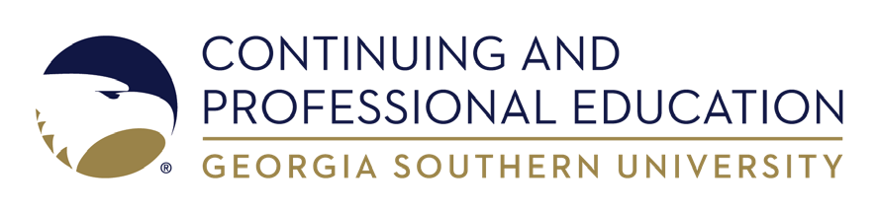
Questions?
Phone: 912-478-5555
Email: cpe@georgiasouthern.edu

